There are several ways to obtain objects to 3d print.
A primary objective would be to encourage students to use Tinkercad to design their own objects to 3d print. It is done fully through the browser on their chromebook. Students can use their existing google username/password to log in to Tinkercad.

To get you familiar with the 3d printing process, you can also find objects already designed by others that are ready to print.
You can go to Thingiverse and download a pre-made object and Enter a search term or click on Education to find lessons.

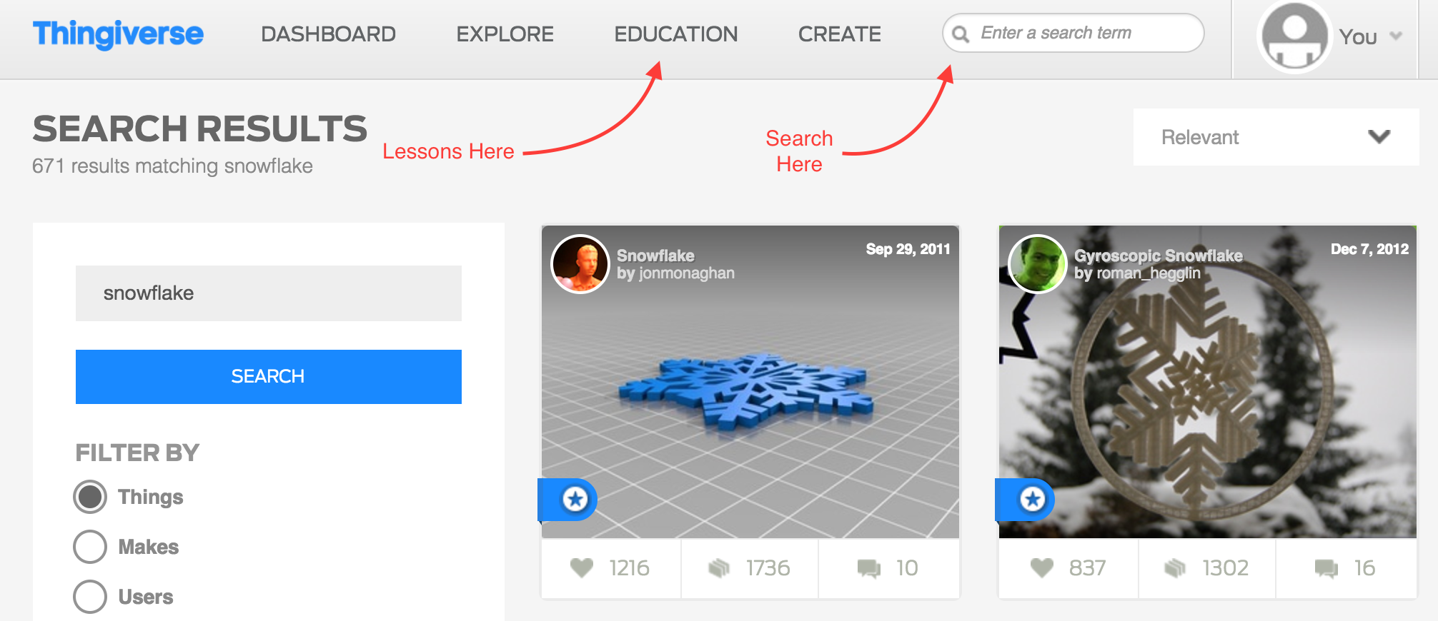

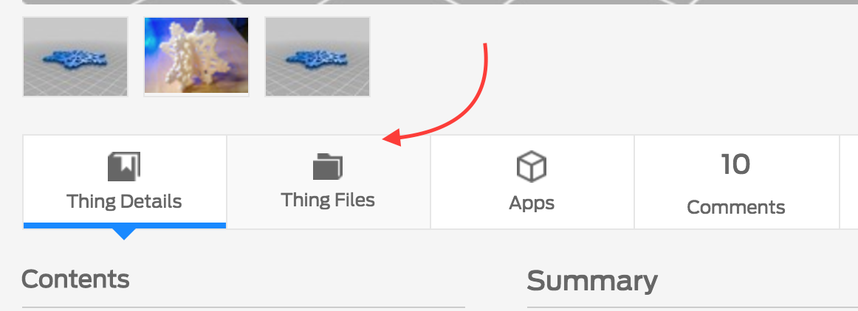

Find an item to print and select Thing Files to see a list of files. Download the file with a .STL extension

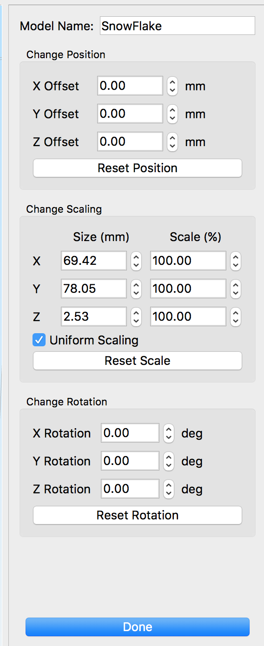

Open Simplify3d. This program gives the 3d printer its instructions to print the 3d object.
You can also get to Simplify3d by simply clicking on the download in google chrome once it is complete.

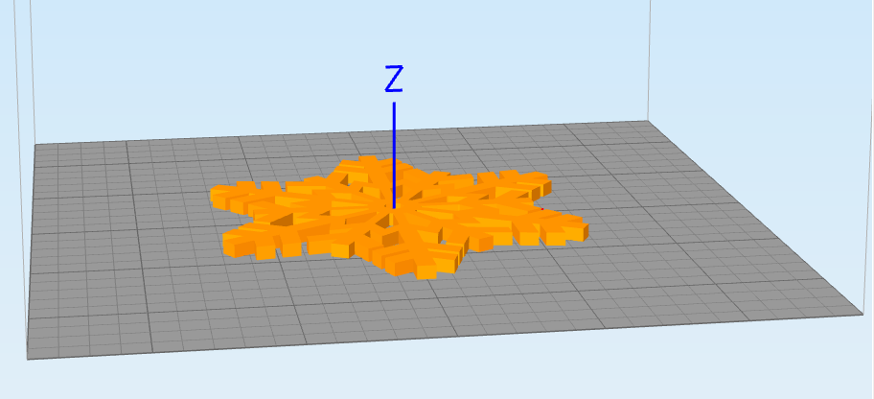
Double-Click on the orange object to bring up the X Y Z menu. You can Adjust the rotation and scaling here to fit your needs. You’ll want to think about the direction it is going to print as it will need supports if there are empty spaces or overhangs. For Example, you wouldn’t want to print this snowflake standing up because there would be empty space the printer would have to bridge with material. You want to print it laying down so it doesn’t need any additional supports to be printed.

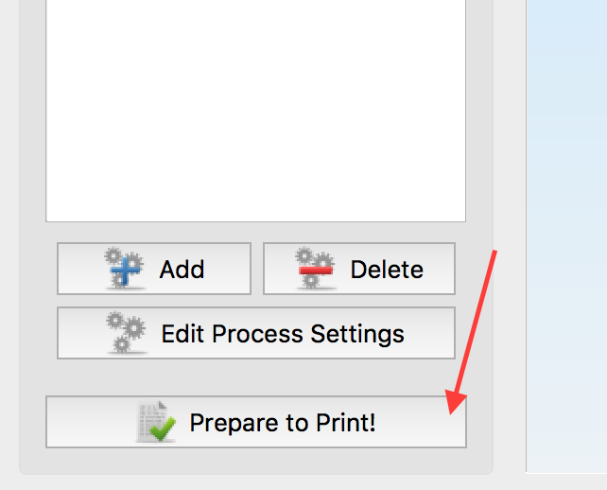
To print, click Prepare to Print

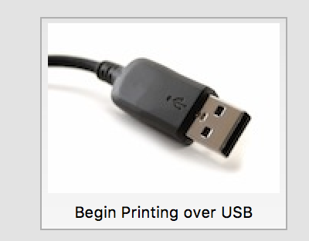
Make sure the 3d printer is on. Press the black button on the front if the lcd panel is not displaying
Click Begin Printing over USB to send the job to the printer.
The printer will take a few minutes to warm up the nozzle and start printing.
Check to make sure the printer prints the first few layers successfully. If there are any issues, turn off the printer and submit a help desk ticket via email to helpdesk@maumeek12.org

